Tobacco-Free RP
Developing Youth Display Boards for NYS parks information centers: RP Marketing. Creative will be shared August 2 EOD.
Activity page: Coloring on one side and facts for parents on back
Plog Event: August 20th
A new running activity hitting the shores of America from Sweden-Plogging, Participants run and pick up trash along the route.
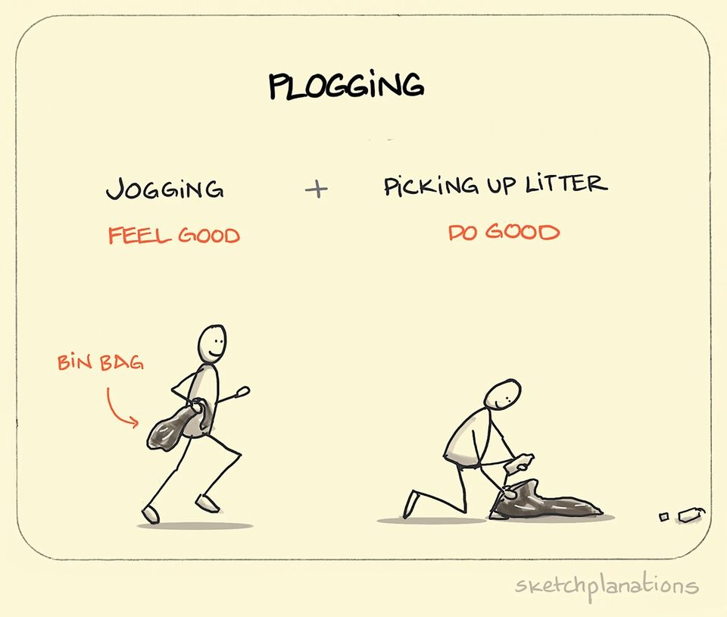
Saturday August 20th at 11am at Flying Bison Brewery.
3 Routes-6 mile and 4 mile run and 2 mile walk from the brewery.
We supply the cloves, trash bags and maps for the routes!
Also, Paula’s Donuts, fruit and snacks before and after the run PLUS $5 pints post run. Saucony Demo Day as well.
Special guests Green Buffalo, lululemon, Runner Roost and Tobacco Free WNY!
Come on down and get a run in while helping clean up the city!
- Sharing teaser promo posts on TFWNY social
- Blog about a plog
- Earned media strategy: Jenna’s talking points at event will include discussion of Kick Butts Collaborative and tobacco litter efforts/beautification in 800 block of Main Street.
Earned Media: Joint release with partners. Buffalo News and Spectrum covering.
July: 908 web site visitors; up 60% from June
I attribute this to:
-CCA and GOW Summer outreach activities: Fairs (CHQ and CATT and Orleans counties),
- Batavia Children’s Summer Safety Carnival, Migrant and Farm Safety event
- TF-GOW Feature posts on Orleans and Wyoming Counties Chambers of Commerce social channel and e-newsletter
- Presence of Blooms Not Butts Garden Walksposters at all garden walks, Boater safety display
-Feature blog on web home page on Kick Butts Collaborative and tobacco product litter
ATFC
-The statewide It’s Not Just LGBTQ+ digital campaign released in August/early September
-Working with Pride Center on distribution to key stakeholders in media. Also connecting with Maansi and attending Aug. 25 RP LGBTQ committee mtg to share digital assets with the larger institute group to get input on dissemination.
-Reality Check Youth Summit:
- Writing blog, regular social posts on all social platforms and writing post summit press releases with photos and quotes from youth.
- For CCA pubs (Olean, Wellsville, Jamestown, Dunkirk) will pitch a more comprehensive Youth Summit story which will highlight Jon and Ken’s expertise and leadership in growing youth advocates and bringing together a national network of youth organizations to promote tobacco-free living and fight Big Tobacco. Will include the poster they presented at NCTOH.
- Working on getting Yvonne approvals for TFWNY website hosting, Constant Contact, and Adobe accounts for team.

